Module Two: WASH in Emergencies

Gerdien Seegers

Strategia Academy

1. Why is hand washing an essential aspect in WASH interventions?

According to Franks, A. (1998) hand washing is essential because it is an efficient way to remove germs which can be the cause of several illnesses. Those germs can be everywhere: on objects, kitchen utensils, hands, food (meat) etc. People easily transmit them by touching objects, animals, food, shaking hands, rubbing eyes and taking care of small children. So, it is important that people wash their hands regularly. People should at least wash their hands after toilet use (defecation), diaper change, handling garbage, before preparation of food and after contact with animals.

Handwashing prevents several illnesses. The most important are:

1. Diarrheal Diseases and Acute Respiratory Infections like diarrhea, pneumonia
2. Bacterial Infections like E-coli, cholera, pneumonia, Typhoid
3. Viral Infections like Ebola, Hepatitis A

Children under the age of five are very sensitive to diseases like diarrhea and pneumonia. Also, pregnant women, elderly and sick people are more susceptible to diseases caused by lack of hygiene. According to a study performed by Kumar, S. et al (2013) handwashing with soap can reduce the risk of diarrhea episodes by 30–47% and respiratory infections by 23%. To remove the germs, it is important to wash hands with soap. Hands can be washed without soap but according to a study by Luby, S, et al (2011) it is more effective to remove germs using soap. Washing hands before preparing food, reduces the cases of childhood diarrhea enormously.

According to the Global Handwashing Partnership (2017) handwashing is also very important in health clinics and hospitals. Bad hygiene, also caused by lack of hand washing habits, causes 15,5% of the Healthcare-Related Risks of Poor Hygiene infections. Lack of good hand washing and other hygiene facilities is still very common, especially in clinics in rural areas.

The WHO has developed the Five Moments for Hand Hygiene in clinics:

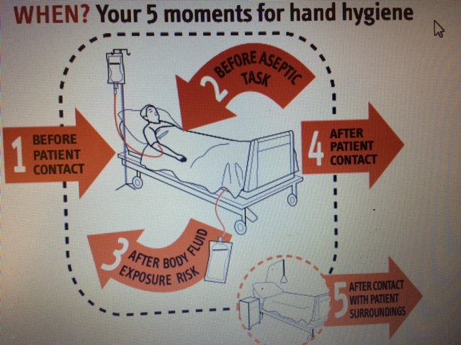

Figure 1 Source: WHO

Mlcak,R. et al (2012) states that handwashing is the single most important procedure to prevent nosocomial infections (Hospital Acquired Infections). If the process of handwashing is not performed properly than other actions like cleaning or sterilization of the instruments are useless.

1. What are the main standards in WASH interventions in emergencies?

According the Sphere handbook there are 6 main standards for WASH in emergencies:

Water supply, sanitation and hygiene promotion:

* 1. Hygiene promotion
  2. Water Supply
  3. Excreta disposal
  4. Vector Control
  5. Solid waste management
  6. Drainage

There is of course a difference of the situation in communities affected by natural disasters like floods, cyclones, earthquakes or tsunamis and communities that have to flee because of conflicts. The last ones normally end up in refugee camps where organizations like UNHCR and Unicef

will setup the necessary infrastructure that officially is temporary. UNHCR states that ‘all water supply and distribution systems established for the use of refugee communities should be conceived taking into account that their operation and maintenance requirements differ from those of a normal (local) village or town, as the economic and social bases of refugee groupings differ from those of the host communities’.

If people can stay in their villages (or in temporary shelters nearby) the principle is building back better.

**Sphere** **WASH standard 1**

WASH programme design and implementation. WASH needs of the affected population are met and users are involved in the design, management and maintenance of the facilities where appropriate.

Ad 2.1 **Sphere** **Hygiene promotion standard 1**

Hygiene promotion implementation. Affected men, women and children of all ages are aware of key public health risks and are mobilized to adopt measures to prevent the deterioration in hygienic conditions and to use and maintain the facilities provided.

**Sphere Hygiene promotion standard 2**

The disaster-affected population has access to and is involved in identifying and promoting the use of hygiene items to ensure personal hygiene, health, dignity and well-being.

Hygiene promotion. According UNHCR Emergency handbook (2007) hygiene promotion “is a planned, systematic approach that enables people to act in a manner that ensures that water, sanitation and hygiene facilities and services have an impact on health”. It is important that people affected by disasters are aware of the importance of the services installed and use them in a proper way and provide the necessary maintenance. It is important that people have access to those services to ensure personal hygiene, health, dignity and well-being-Sphere Handbook (2011). The most relevant indicators developed by UNHCR measure the presence of soap for handwashing and the number of hygiene promoters per refugee. Of course, awareness is also very important to guarantee handwashing and further personal hygiene.

Ad 2.2 **Sphere Water supply standard 1**

Access and water quantity. All people have safe and equitable access to a sufficient quantity of water for drinking, cooking and personal and domestic hygiene. Public water points are sufficiently close to households to enable use of the minimum water requirement.

**Sphere Water supply standard 2**

Water quality. Water is palatable and of sufficient quality to be drunk and used for cooking and personal and domestic hygiene without causing risk to health

**Sphere Water supply standard 3**

Water facilities. People have adequate facilities to collect, store and use sufficient quantities of water for drinking, cooking and personal hygiene, and to ensure that drinking water remains safe until it is consumed.

Also, for the water quality and quantity during emergencies organizations like WHO, UNICEF, the Sphere Project and UNHCR have developed guidelines. During emergencies it is important to assess the situation as quick as possible before setting up the necessary infrastructure. It is important to have an overview of the available sources of water and the level and type of contamination. They UNHCR (2007) maintains 6 principles of response and prioritizes the quantity of water over quality. Focus is on the provision of sufficient water and at the same time avoiding over exploitation of the sources and avoid the need to treat the water. Thomas (2015) states that the standard of the quantity of water that should be available during emergencies is as follows:

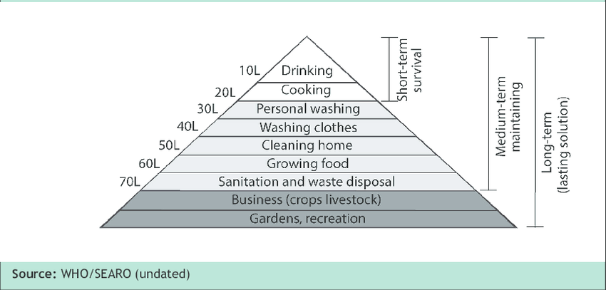

Figure 2 Source: Thomas (2015)

The WHO developed guidelines with a very detailed display of all existing variations of microbial hazards(pathogens) and chemical contaminants- WHO (2011). WHO quality standards for safe water are the minimum requirements for safe water. The UN-Water (2013) definition of water security concerns ‘the access to adequate quantity and acceptable quality water for sustaining livelihoods, human well-being, and socio-economic development, for ensuring protection against water-borne pollution and water-related disasters, and for preserving ecosystems in a climate of peace and political stability’. But for emergencies Sphere (2007) defines the minimum humanitarian standards for fetching water at a maximum of 500 meters and a queuing time of 30 minutes maximum, which would translate into a round trip of less than 60 minutes.

Ad 2.3 **Sphere Excreta disposal standard 1**

Environment free from human feces. The living environment in general and specifically the habitat, food production areas, public centers and surroundings of drinking water sources are free from human fecal contamination.

**Sphere Excreta disposal standard 2**

Appropriate and adequate toilet facilities. People have adequate, appropriate and acceptable toilet facilities, sufficiently close to their dwellings, to allow rapid, safe and secure access at all times, day and night.

According to the WHO (2013) ‘The main objective for an excreta disposal programme is to minimize contamination related to high-risk practices and reduce exposure and fecal-oral disease transmission.’ After a natural disaster or a conflict that makes people flee to a refugee camp an assessment has to be implemented to learn to know the basic needs concerning sanitation: toilets and latrines. Immediately after the disaster there are no well- functioning sanitation services or no sanitation services at all. Open air defecation will be practiced, and it is important to organize that to avoid a situation where illnesses can be transmitted easily. A separate field can have that function till a proper infrastructure has been built. It is important that excreta will be covered with sand and that hand wash facilities are nearby.

The assessment not only looks at the technical needs, geological situation, situation as it was before for setting up an infrastructure but also the cultural habits and traditions around sanitation.

What we see in emergencies situations is that over time the sanitation infrastructure develops from very basic (open defecation field) to a more sophisticated infrastructure that can be used for a couple of years (or longer).

Ad 2.4 **Vector Control.**

According to Sphere Handbook (2011) ‘A vector is a disease-carrying agent and vector-borne diseases are a major cause of sickness and death in many disaster situations.’ Lacarin, C. (1999) states that the major causes of diseases in the tropics are caused by three vectors: arthropods (insect or arachnid), snails and rodents.

Some of the vectors bite (mosquito, snail) and others transmit diseases directly or indirectly from infected human to another human or from animal to human according to Lacarin, C. (1999). Besides biting this can happen via excreta, urine or saliva (rats), penetration (worms), or the gastrointestinal tract (food and drinks).

**Sphere Vector control standard 1**

Individual and family protection: people need to understand what vectors are and how they transmit diseases, so they can protect themselves. It is important that people have access to resources to protect themselves (mosquito nets, repellent, food storage) and to vector free places (shelters).

**Sphere Vector control standard 2**

Physical, environmental and chemical protection measures: disaster affected people live in an environment where vectors are not a threat. Camps should not be placed near a water source and flies, rats, mosquitoes etc. must be controlled by taking care of responsible excreta disposal, tap latrines, waste management and cover water storage (breeding place mosquitoes).

**Sphere Vector control standard 3**

Chemical control safety: if the choice for chemical vector control is made it is important to avoid chemical resistance. This can be done by protecting people that apply the chemicals and inform and protect the disaster-affected population.

Lacarin,C. (1999) also mentions biological vector control like fly traps and biological insecticide. These could be a good and healthier alternative especially since the chemical vector control can cause chemical resistance.

Ad 2.5 **Sphere Solid waste management standard 1**

Collection and disposal. It is important that all kinds of waste are collected and disposed of in an orderly and hygienic way. (see question 3 hereunder)

Ad 2.6 **Sphere Drainage standard 1**

Drainage work. People have an environment in which health risks and other risks posed by water erosion and standing water, including stormwater, floodwater, domestic wastewater and wastewater from medical facilities, are minimized. According to Bjerregaard, M. (2008) drainage is perhaps not a priority during an emergency, but ‘should be considered after the immediate water, sanitation and hygiene needs have been met’. Floods cause latrines to overflow and if waste water is not managed well it can cause health problems in refugee camps and communities hit by natural disaster. People, especially small children, can also drown if there are big puddles of water in the villages. Still standing water is an ideal breeding place for vectors.

1. Waste Management is becoming one problem in the emergencies. Why?

According to Bjerregaard, M. (2011) ‘Disaster waste is a well-recognized threat to health, safety and the environment, and can also be a major impediment to post-disaster rescue operations’. .In this assignment the focus is on solid and liquid waste. The management of dead bodies is according to Morgan (2006) often overlooked in disaster planning but will not be discussed in this assignment. Waste management in emergencies is always a problem but the degree to which is dependent on the type of disaster. Floods can cause overflowing of latrines, “cleaning” garbage dumps and according to Bjerregaard, M. (2011) waste mixes with hazardous materials.

Earthquakes destroy the infrastructure turn buildings into rubble and sometimes also this contains asbestos. Cyclones can spread existing rubbish over a large surface and turn houses, cars etc in rubbish. Bjerregaard, M. (2011) remarks that also boats can land and roofing material including asbestos is hurled around. A Tsunami can cause a huge amount of debris and trees. Conflicts, short and protracted, can according to Bjerregaard ,M.(2011) leave the area with bombs, mines and booby traps. In all cases the infrastructure is damaged and the access for lorries to pick up the garbage is limited. Also, the infrastructure to store, process and/or recycle the waste can be damaged. Solid waste can also contain medical waste, excreta or other waste that can cause severe health problems. It can attract rodents that can spread diseases.

According the Sphere Project (2011) most waste in a refugee camp consists of organic matter. If this waste is not managed well it can cause health problems because it attracts animals like rats.

Besides the waste mentioned above, the emergency situation creates its own waste because often sanitation structure is damaged, and people have no access to toilets/latrines and have to revert to open air defecation. The emergency hospitals also create new waste and if not taken care of properly, this can also cause a problem.

1. Discuss how environmental health and sanitation affect the nutritional status of the vulnerable groups

If people live in areas where good sanitation and healthcare is lacking they are more susceptible to diseases. According to Freeman, M. et al (2017) bad sanitation can cause infectious diseases and influence the nutritional situation of especially vulnerable people. Diarrhea causes an estimated

1.4 million deaths a year. A billion of people are at risk of soil-transmitted helminth -Murray et al (2103) and trachoma causes worldwide 2.2 million people with visual impairment and 1.2 million blind people according to Pascolini, D. (2013).

Infectious diseases can cause undernutrition. But it is also possible to reason the other way around by stating that undernourished people are more receptive for diseases like trachoma and diarrhea. See Gezahegn,T. (2016). Undernutrition is defined by UNICEF (2016) as ‘the outcome of insufficient food intake and repeated infectious diseases’. The infectious diseases are directly or indirectly the result of poor WASH.

Figure 3 shows the relation between poor WASH and nutritional status. It shows how fecal bacteria can go directly and indirectly to humans. Humphrey (2009) states that poor WASH can cause indigestion ‘of fecal pathogens, which leads to diarrhea, intestinal worms and environmental enteric dysfunction’. The direct consequence of this is that the body cannot absorb nutrients from the food. According to Lapegue, J. (2014) other water and sanitation-related illnesses (e.g. malaria, dengue, leishmaniasis, trypanosomiasis, yellow fever), together with chronic poisoning due to poor chemical quality of water, also contribute to the deterioration of nutritional status.

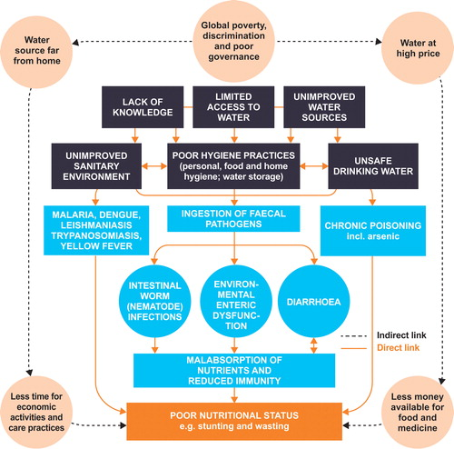

Figure 3 Source: Lapegue J, 2014

1. Assuming you have been appointed to head an organization dealing with health development in your area, describe the critical factors you will consider in the planning for health service in that area

Kikukawa,L. (2017) states that for setting up a rural health facility it is important to take in consideration the uniqueness of a community. Before starting a survey, it is important to connect to local leaders and knowledgeable people. They can be a rich source of information concerning needs and local habits. The survey will not only give an insight in the socio-economic situation of the population but also the actual health infrastructure and the way people look at western and traditional medicine. Kikuwa,L. (2017) shows that it is also important to take the geographical situation in consideration. Is the area easy, accessible by ambulances and or helicopters? Another important factor is the population structure. A population with a majority of young people has

other needs than a population with more elderly people. The survey also will pay attention to demand, health and the economic situation of the different groups in a community. Have people access to health insurance?

After implementation of the community survey it is important to organize meetings with local and district health officers of the government. They are familiar with the national health plan and budget and with them it is possible to discuss and define the plan for the health facility. After the decision concerning the definitive kind of facility- primary health care center- the building of a new facility or the rebuilding of an existing one can start. Since it concerns a rural clinic it will be important that the clinic can treat most of the illnesses and diseases that come out of the survey. Only for more specialized treatments people will be referred to an urban hospital.

The clinic needs to dispose off enough medical supplies and the appropriate storage facility. The clinic needs also a proper WASH infrastructure and a separate women’s wing.

Hiring staff is the next step and one of the most challenging. According to the World Health Organization (2013) ‘there is a deficit in health care professionals all over the world, which is especially pronounced in rural areas of developing or low-income countries.’ Therefore, Strasser et al (2016) states that local students should be included and trained so they can deliver quality health care to their own communities. In 2016 Member States of the 69th World Health Assembly adopted a strategy and resolution to address human resources for health (HRH) challenges and achieve Universal Health Coverage (WHO 2016).

Training of the local students will take some time, and in the meantime specialized staff like doctors and nurses need to be contracted. This is not easy because people are educated in a city and are not very eager to work in a rural setting. An easy solution is to try to hire international staff but that is not a sustainable solution. Here the local government will have to take its responsibility. In some countries an obligatory social service exists for health personnel. They must work up to two years in the rural area before they are allowed to work in an urban setting. Percy, M. et al (2014) describe how this system was first implemented in 1936 in Mexico and later in other Latin American countries. The principle of the system was that the state invested in the students and asked something in return (reciprocity). The study performed by Percy, M. et al (2014) showed that this system had the image to be rather paternalistic and had no sustainable impact. It is not only legally contestable but people in remote areas are also entitled to high quality services provided by motivated staff.

Besides the specialized staff the clinic will also need community health workers. After a basic training they can work in the communities and according to Madon, S. et al (2018) community health workers have better access to the communities and have also a better understanding of their needs. Ideally the workers can also be trained in good WASH practices, so they can extend their involvement.

References

Bjerregaard, M. and M. Meekings, H. (2008), Oxfam, Low cost drainage for emergencies, Technical briefing

Bjerregaard,M. et al (2011) Disaster Waste Management Guidelines, Published in Switzerland by the Joint UNEP/OCHA Environment Unit

Freeman, M et al (2017) The impact of sanitation on infectious disease and nutritional status:

A systematic review and meta-analysis, International Journal of Hygiene and Environmental Health

Gezahegn,T. et al (2016), Psychiatry Journal, 21-11-2016

Kikukawa, L. (2017), Hawai’i Journal of Medicine and Public Health, March 2017

Kumar, S. et al (2013) Handwashing in 51 countries: analysis of proxy measures of handwashing behavior in multiple indicator cluster surveys and demographic and health

Surveys

Lacarin, C.and Reed B (1999). Emergency vector control using chemicals, Loughborough University, 1999

Madon,S. (2018), The role of community participation for sustainable integrated neglected tropical diseases and water, sanitation and hygiene intervention programs : A pilot project in Tanzania, Social Science & Medicine 202

Mlack R. et al (2012) Total Burn Care, 4th EditionMorgan, O (2006) -- ed Management of dead bodies after disasters: a field manual for first responders. Washington, D.C

Murray, C. et al (2013) Disability-adjusted life years (DALYS) for 291 diseases and injuries in 121 regions, 1990-2010: a systematic analysis for the Global Burden of Disease Study, Lancet 380

Pascolini, D. and Mariotti, S. (2012), Global Estimates of visual impairment, Br.J. Opthamol 96

The Sphere Project (April 2011), Sphere Handbook

Strasser,R. et al (2016) Rural health care access and policy in developing countries, Annual Review Public Health 2016

# Thomas, V. (2015) Household water insecurity: changing paradigm for better framing the realities of sustainable access to drinking water in Afghanistan -Discussion Paper

United Nations (UN)-Water (2013). Water security and the global water agenda. A UN-Water Analytical Brief.” Ontario:

United Nations High Commissioner for Refugees (UNHCR 2007) Handbook for emergencies, United Nations High Commissioner for Refugees, Geneva Third Edition

United Nations High Commissioner for Refugees (UNHCR 1992) Water manual for refugee situations

World Health Organization (WHO 2011), Guidelines for drinking-water quality - 4th ed. (Geneva)

World Health Organization (WHO 2013) Water Engineering and Development Centre (WEDC) Technical notes 9 and 13 on Drinking water, hygiene and sanitation in emergencies

The World Health Organization (WHO 2013) report A universal truth: no health without a workforce was prepared for the Third Global Forum on Human Resources for Health held in November 2013 in Recife, Brazil

Web References

Franks, A. et al (1998). [Variations of bacterial populations in human feces measured by fluorescent in situ hybridization with group-specific 16S rRNA-targeted oligonucleotide probes.](http://www.ncbi.nlm.nih.gov/pmc/articles/PMC106730/) Retrieved from http://[www.ncbi.nlm.nih.gov/pmc/articles/pmc106730/](http://www.ncbi.nlm.nih.gov/pmc/articles/pmc106730/)

<https://globalhandwashing.org/wp-content/uploads/2017/08/GHP-Hygiene-in-HCFs-Fact-Sheet-Aug2017.pdf>

Humphrey, J. (2009) ‘Child undernutrition, tropical enteropathy, toilets, and handwashing’, The Lancet 374(9694): 1032–5 Retrieved from <http://dx.doi.org/10.1016/S0140-6736(09)60950-8>

Lapegue, J. (2014), Action Contre le Faim, retrieved from http://[www.actioncontrelefaim.org/en/content/factsheet-wash-nutrition](http://www.actioncontrelefaim.org/en/content/factsheet-wash-nutrition)

# Luby,S. (June 2018) The effect of handwashing at recommended times with water alone and with soap on child diarrhea in rural Bangladesh: An Observational Study. Retrieved from <http://journals.plos.org/plosmedicine/article?id=10.1371/journal.pmed.1001052>

# Percy, MT. (2014), **El requisito obligatorio del servicio social en salud del Perú: discriminatorio e inconstitucional. Retrieved from http://www.scielo.org.pe/scielo.php?script=sci_arttext&pid=S1726-46342014000400026**

<http://www.who.int/gpsc/tools/Five_moments/en/>

# <https://www.unicef.org/nutrition/index_faces-of-malnutrition.html> July 2016

<http://www.who.int/workforcealliance/media/news/2016/ghwa_wha16_global-momentum/en/>